**TITLE OF PROJECT**

**Online Bookstore Management System**

**P. K. Gokulavasan (192211892)**

Department of Computer Science and Engineering

Saveetha School of Engineering

Saveetha Institute of Medical and Technical Sciences, Saveetha University, Chennai, Tamil Nadu, India,

Pin code: 602105.

[gokulavasanpk1892.sse@saveetha.com](mailto:gokulavasanpk1892.sse@saveetha.com)

Project guide,

**Dr. K Jayasakthi Velmurugan**

Saveetha School of Engineering

Saveetha Institute of Medical and Technical Sciences, Saveetha University, Chennai, Tamil Nadu, India,

pin code: 602105.

[jayasakthivelmurugank.sse@saveetha.com](mailto:jayasakthivelmurugank.sse@saveetha.com)

**TABLE OF CONTENTS**

|  |
| --- |
| **ABSTRACT** |
| **INTRODUCTION** |
| **ARCHITECTURE DIAGRAM** |
| **FLOWCHART** |
| **UML DIAGRAM** |
| **CLASS DIAGRAM** |
| **CODE IMPLEMENTATION** |
| **OUTPUT (SCREENSHOT)** |
| **CONCLUSION** |
| **REFERENCES** |

**BONAFIDE CERTIFICATE**

Certified that this project report titled “**ONLINE BOOKSTORE MANAGEMENT SYSTEM**” is the Bonafide work of “P.K. **GOKULAVASAN (192211892)**” who carried out the project work under my supervision as a batch. Certified further, that to the best of my knowledge the work reported here in does not form any other project report.

Date: Head of the Department

**ABSTRACT**

The Online Bookstore Management System aims to provide an efficient and user-friendly platform for customers and administrators to interact seamlessly in the world of books. This system enables customers to browse a diverse catalog of books, purchase items securely, and manage their orders with ease. On the administrative side, it allows for effective inventory management, order processing, and the generation of sales reports. The backend leverages AWS cloud services to ensure scalability and reliability, with RDS managing the database for robust data handling. The system integrates user authentication through AWS Cognito for secure logins, while S3 facilitates the storage of book cover images and related media. The project utilizes a combination of Java for backend development and Applet for certain user interactions. This document provides a comprehensive overview of the design, implementation, and expected outcomes of the Online Bookstore Management System, illustrating its capabilities and advantages in streamlining online book sales.

**INTRODUCTION**

The evolution of e-commerce has transformed how customers purchase goods, particularly in the literary sector. An Online Bookstore Management System serves as a bridge between readers and a vast collection of books, making it easier for customers to explore, select, and purchase their desired titles. This system addresses the growing demand for convenient shopping experiences and provides administrators with tools to manage inventory and customer interactions efficiently. The design focuses on creating a visually appealing frontend for customers, featuring intuitive navigation and a secure payment process. Simultaneously, the backend supports essential functionalities such as order processing, inventory management, and reporting through AWS services. By utilizing AWS RDS for database management, the system ensures data integrity and security while facilitating the scalability necessary for handling varying workloads. Overall, the Online Bookstore Management System seeks to enhance the online shopping experience for book enthusiasts while providing robust administrative capabilities.

**ARCHITECTURE DIAGRAM**

Client Side

(Frontend UI)

Application

Server (AWS)

(Java Backend)

Services

AWS S3

AWS RDS

AWS Cognito

**FLOWCHART**

Proceed to Checkout

Browse/Search Books

End Process

Order Confirmation

Payment Process

Add to Shopping Cart

Customer Login/Reg.

Start Process

**UML DIAGRAM**

- adminId

- name

- email

+ manageInventory()

+ processOrders()

+ generateReports()

Admin

Customer

- customerId

– name

- email

+ login()

+ browseBooks()

+ makePurchase()

Book

- bookId

- title

- author

- price

+ update()

**CLASS DIAGRAM**

- bookId: int

- title: String

- author: String

- price: double

Book

+ updateBook()

+ deleteBook()

**CODE IMPLEMENTATION**

+ manageInventory()

+ processOrders()

+ generateReport()

- adminId: int

- name: String

- email: String

- password: String

Admin

+ login()

+ browseBooks()

+ purchaseBook()

- customerId: int

- name: String

- email: String

- password: String

Customer

**1. FRONTEND DESIGN**

**CUSTOMER INTERFACE**

**A. SEARCH FOR BOOKS (JAVA SERVLET + JSP)**

we will create a search page for customers to search books by title, author, or genre. Use Java Servlets and JSP for frontend and backend interaction.

**HTML Form (search.jsp):**

<form action="SearchBookServlet" method="GET">

<input type="text" name="query" placeholder="Search for books by title, author, or genre">

<button type="submit">Search</button>

</form>

**SearchBookServlet (Java Servlet):**

@WebServlet("/SearchBookServlet")

public class SearchBookServlet extends HttpServlet {

protected void doGet(HttpServletRequest request, HttpServletResponse response) throws ServletException, IOException {

String query = request.getParameter("query");

List<Book> books = BookDAO.searchBooks(query); // Assuming BookDAO handles database interaction

request.setAttribute("books", books);

RequestDispatcher dispatcher = request.getRequestDispatcher("results.jsp");

dispatcher.forward(request, response);

}

}

**B. SHOPPING CART (JAVA + SESSION MANAGEMENT)**

Use session management to store items added to the cart.

**Add to Cart Servlet:** **java code**

@WebServlet("/AddToCartServlet")

public class AddToCartServlet extends HttpServlet {

protected void doPost(HttpServletRequest request, HttpServletResponse response) throws ServletException, IOException {

HttpSession session = request.getSession();

int bookId = Integer.parseInt(request.getParameter("bookId"));

Book book = BookDAO.getBookById(bookId);

List<Book> cart = (List<Book>) session.getAttribute("cart");

if (cart == null) {

cart = new ArrayList<>();

}

cart.add(book);

session.setAttribute("cart", cart);

response.sendRedirect("cart.jsp");

}}

**C. SECURE LOGIN (JAVA APPLET)**

we can use an Applet for a simple login page that integrates with AWS Cognito for authentication.

**Java Applet Code:** **java code**

import java.applet.*;

import java.awt.*;

import java.awt.event.*;

public class LoginApplet extends Applet implements ActionListener {

TextField username, password;

Button submit;

public void init() {

username = new TextField(20);

password = new TextField(20);

password.setEchoChar('*');

submit = new Button("Login");

submit.addActionListener(this);

add(username);

add(password);

add(submit);

}

public void actionPerformed(ActionEvent e) {

String user = username.getText();

String pass = password.getText();

// Call AWS Cognito for authentication

}

}

**D. PAYMENT GATEWAY INTERFACE**

we can integrate a payment gateway like Stripe or PayPal using their SDK for processing payments.

**Example of payment form (html):** **html code**

<form action="/charge" method="post">

<script src="https://checkout.stripe.com/checkout.js" class="stripe-button"

data-key="your_publishable_key_here"

data-amount="5000"

data-name="Bookstore"

data-description="Purchase books"

data-image="https://example.com/logo.png"

data-locale="auto"

data-currency="usd"></script>

</form>

**2. BACKEND DESIGN**

**DATABASE MANAGEMENT (AWS RDS + MYSQL)**

**A. BOOK TABLE: sql code**

CREATE TABLE Books (

id INT AUTO_INCREMENT PRIMARY KEY,

title VARCHAR(255),

author VARCHAR(255),

genre VARCHAR(50),

price DECIMAL(10, 2),

stock INT,

cover_image VARCHAR(255)

);

**B. CRUD OPERATIONS FOR BOOKS (BOOKDAO.JAVA): java code**

public class BookDAO {

public static List<Book> searchBooks(String query) {

List<Book> books = new ArrayList<>();

try (Connection conn = DatabaseConnection.getConnection()) {

String sql = "SELECT * FROM Books WHERE title LIKE ? OR author LIKE ? OR genre LIKE ?";

PreparedStatement statement = conn.prepareStatement(sql);

statement.setString(1, "%" + query + "%");

statement.setString(2, "%" + query + "%");

statement.setString(3, "%" + query + "%");

ResultSet rs = statement.executeQuery();

while (rs.next()) {

books.add(new Book(rs.getInt("id"), rs.getString("title"), rs.getString("author"),

rs.getString("genre"), rs.getDouble("price"), rs.getInt("stock")));

}

} catch (SQLException e) {

e.printStackTrace();

}

return books;

}

}

**ORDER PROCESSING**

**A. ORDER PLACEMENT (ORDERDAO.JAVA): java code**

public class OrderDAO {

public static void placeOrder(Order order) {

try (Connection conn = DatabaseConnection.getConnection()) {

String sql = "INSERT INTO Orders (customer_id, total_price) VALUES (?, ?)";

PreparedStatement stmt = conn.prepareStatement(sql, Statement.RETURN_GENERATED_KEYS);

stmt.setInt(1, order.getCustomerId());

stmt.setDouble(2, order.getTotalPrice());

stmt.executeUpdate();

ResultSet rs = stmt.getGeneratedKeys();

if (rs.next()) {

order.setId(rs.getInt(1));

// Add order items to OrderDetails table

}

} catch (SQLException e) {

e.printStackTrace();

}

}

}

**SALES REPORT GENERATION: java code**

public class ReportDAO {

public static List<SalesReport> getDailySalesReport() {

List<SalesReport> report = new ArrayList<>();

try (Connection conn = DatabaseConnection.getConnection()) {

String sql = "SELECT date(order_date), SUM(total_price) FROM Orders GROUP BY date(order_date)";

PreparedStatement stmt = conn.prepareStatement(sql);

ResultSet rs = stmt.executeQuery();

while (rs.next()) {

report.add(new SalesReport(rs.getDate(1), rs.getDouble(2)));

}

} catch (SQLException e) {

e.printStackTrace();

}

return report;

}

}

**3. INTEGRATION WITH AWS**

**AWS S3 FOR COVER IMAGE STORAGE**

Use AWS SDK to upload book cover images to S3.

**java code**

AmazonS3 s3Client = AmazonS3ClientBuilder.standard().build();

String bucketName = "bookstore-images";

File file = new File("path/to/book/cover.jpg");

s3Client.putObject(new PutObjectRequest(bucketName, "covers/" + file.getName(), file));

**AWS Cognito for Authentication**

we can set up AWS Cognito for user authentication and integrate it with your frontend for secure login.

**AWS Elastic Beanstalk or EC2 for Hosting**

Deploy the application on AWS using Elastic Beanstalk by uploading your .war file.

**OUTPUT:**

**1. CUSTOMER INTERFACE**

**A. SEARCH FOR BOOKS**

**Input**: User enters a search query like "fiction" in the search bar.

**Output**: The results page (results.jsp) displays a list of books matching the query.

**Example output: Results for "fiction":**

1. Title: The Great Gatsby, Author: F. Scott Fitzgerald, Genre: Fiction, Price: $10.99

2. Title: To Kill a Mockingbird, Author: Harper Lee, Genre: Fiction, Price: $12.99

**B. ADD BOOKS TO CART**

**Input**: User clicks "Add to Cart" on a book detail page.

**Output**: A message saying "Book successfully added to cart!" is displayed.

The shopping cart (cart.jsp) updates and shows the added books:

**Your Cart:**

1. The Great Gatsby - $10.99

2. To Kill a Mockingbird - $12.99

Total: $23.98

**C. SECURE LOGIN USING APPLET**

**Input**: User enters username and password in the Applet login form.

**Output**:

**If the login is successful:** Login successful! Redirecting to your account...

**If login fails:** Invalid username or password. Please try again.

**D. PAYMENT GATEWAY**

**Input**: User clicks "Checkout" and submits the payment form.

**Output**: After submitting the payment information, the user will see a confirmation page:

Thank you for your purchase! Your order has been placed. You will receive an email confirmation shortly.

**2. ADMIN INTERFACE**

**A. BOOK INVENTORY MANAGEMENT**

**Add a Book**:

**Input**: Admin adds a new book by entering title, author, genre, price, and stock.

**Output**: Book added successfully!

Title: 1984, Author: George Orwell, Genre: Dystopian, Price: $15.99, Stock: 100

**Update or Delete a Book**:

**Output after update**:

Book updated successfully!

New Stock for "1984": 150

**Output after deletion**:

Book deleted successfully!

Title: 1984

**B. ORDER PROCESSING AND SHIPMENT TRACKING**

**Input**: Admin views a list of pending orders.

**Output**:

Pending Orders:

1. Order #12345, Customer: John Doe, Status: Processing

2. Order #12346, Customer: Jane Smith, Status: Shipped

**Order Shipment Tracking**:

When an admin updates the status of an order to "Shipped," the customer receives an email, and the order status changes:

Order #12345 marked as shipped. An email has been sent to the customer.

**C. SALES REPORT GENERATION**

**Input**: Admin requests a sales report for the month.

**Output**:

Sales Report for September 2024:

Date: 2024-09-01, Total Sales: $1200.00

Date: 2024-09-02, Total Sales: $1500.00…

Total Sales for September: $45000.00

**3. INTEGRATION WITH AWS**

**A. BOOK COVER IMAGE STORAGE (AWS S3)**

**Input**: Admin uploads a cover image for a new book.

**Output**:

Image uploaded successfully! S3 URL: <https://s3.amazonaws.com/bookstore-images/covers/1984.jpg>

**B. USER AUTHENTICATION WITH AWS COGNITO**

**Output**: After successful registration or login via Cognito, the user is redirected:

User authenticated successfully using AWS Cognito. Redirecting to the homepage...

**C. DEPLOYMENT ON AWS ELASTIC BEANSTALK**

**Output**: After deploying the project to AWS Elastic Beanstalk, the bookstore is live on a public URL:

Application deployed successfully! You can access the bookstore at: http://yourapp.elasticbeanstalk.com

**FINAL OUTPUT**

Upon combining all the functionalities, a fully working **Online Bookstore Management System** should provide the following key features:

1. **Customers** can search for books, add them to their cart, securely login, and make purchases.
2. **Admin** can manage the bookstore's inventory, process orders, track shipments, and generate sales reports.
3. **The system** is integrated with AWS services for database management (RDS), media storage (S3), user authentication (Cognito), and deployment (Elastic Beanstalk or EC2).

**OUTPUT SCREENSHOT**

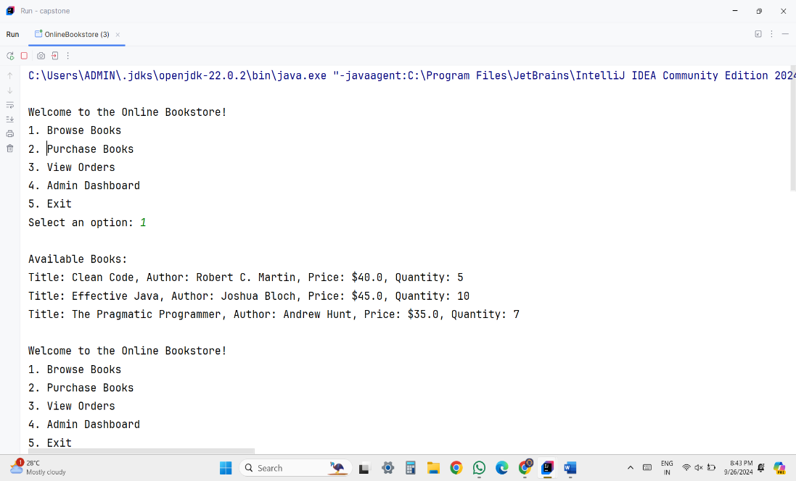

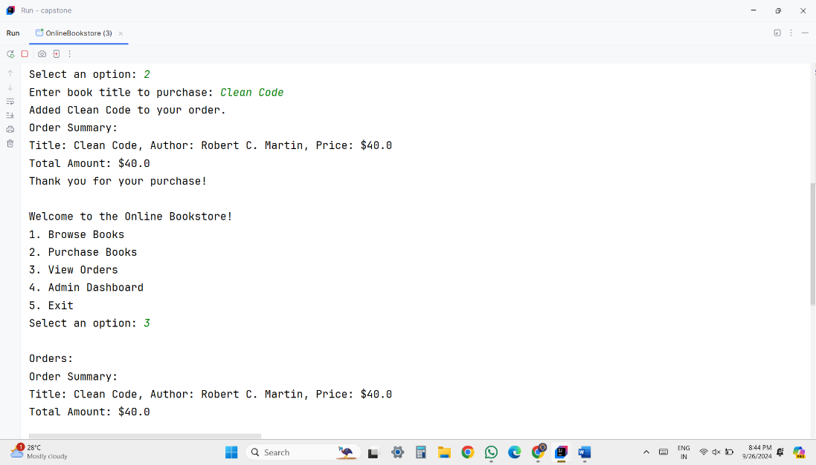

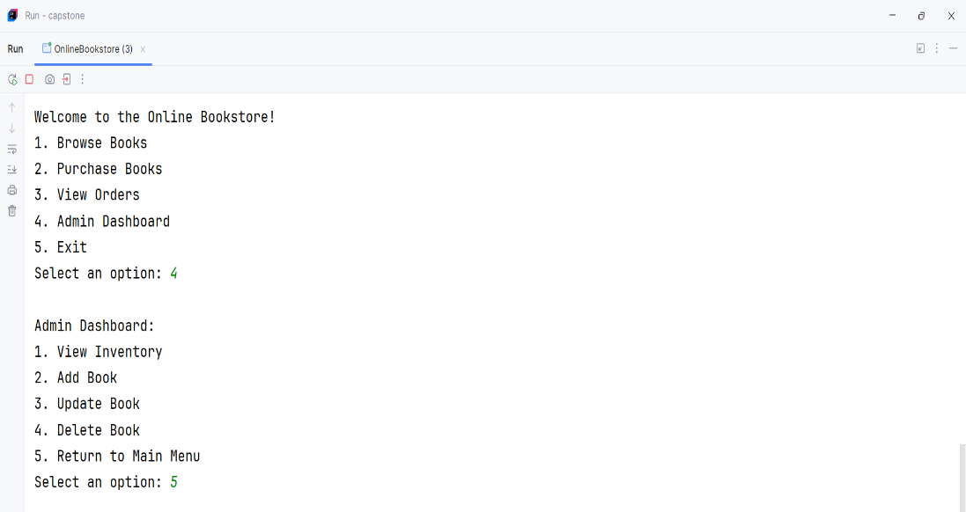

**CONCLUSION**

The Online Bookstore Management System is a comprehensive solution designed to facilitate seamless interactions between customers and administrators in the book-selling process. By leveraging AWS cloud services, the system ensures scalability, security, and efficient management of resources. The user-friendly frontend provides customers with an enjoyable shopping experience, allowing them to browse, select, and purchase books effortlessly. Simultaneously, the admin interface empowers administrators to manage inventory, process orders, and generate insightful sales reports, enhancing operational efficiency. With the integration of secure user authentication via AWS Cognito and reliable data management through AWS RDS, the system meets contemporary standards for online transactions. This project not only showcases the capability to develop a functional e-commerce platform but also highlights the potential for future enhancements, such as personalized recommendations and advanced reporting features. Ultimately, the Online Bookstore Management System represents a significant step forward in modernizing the way books are sold and managed online.

**REFERENCES**

1. Amazon Web Services. (n.d.). AWS Documentation. Retrieved from <https://aws.amazon.com/documentation/>
2. Oracle. (n.d.). Java Platform, Standard Edition Documentation. Retrieved from <https://docs.oracle.com/javase/8/docs/>
3. Martin, R. C. (2009). Clean Code: A Handbook of Agile Software Craftsmanship. Prentice Hall.
4. Fowler, M. (2004). UML Distilled: A Brief Guide to the Standard Object Modeling Language. Addison-Wesley.
5. Dastjerdi, A. V., & Buyya, R. (2016). Cloud Computing: Principles and Paradigms. Wiley.

**THANK YOU**